**Online E-Commerce Grocery Shopping Application**

**Introduction**

Online grocery shop project designed in technologies Node and express at backend, ReactJS for frontend and MongoDB as a backend database connection. It includes client-server architecture.

These Online grocery Shop App is running on browser.

While designing application, we were performing multiple CRUD operations.

**Abstract**

The main objective of Online Grocery shop is to create an online E-Commerce Application for customers to buy and sell the products. You can shop the products from grocery and place the order as per requirement.

**Module or Functionality**

The Main two Actors plays the Role is:

1)ADMIN

2)CUSTOMER

**Admin / Shop Owner**

1)Admin can login into application and manages the available products.

2)Admin can ADD/UPDATE/DELETE the products from shop.

3)Admin can check the records or order history of customers.

4)Admin can view all the transactions like pending order or placed orders.

5)Admin can manage the overall shopping application.

**Customer / User**

1)Customer is going to interact with front actor of application who can view the products and check the price as well and place order according to the requirements.

2)User can view the products.

3)If new Customer comes, he/she have to register to access grocery shop.

(Validation will be provided)

4)User can manage the shopping cart.

5)Users can view the invoice or bill of the complete shopping.

6)User can also manage the transaction history after logging into application.

7)The most important part of application is, user have to login into application to order any products.

Flow for Customer:

Home page -->Product category page-->Product page --->added to cart popup--->login or signup for guest --->show and confirm cart--->order confirmation

**Product Search**

1)Customer can search the product by

* Id
* Name
* Category

**Cart**

1)Customer can ***ADD/DELETE/UPDATE*** products in a cart.

2)Show the cart details.

**Payment Gateway**

1)Visual Representation of Payment Gateway

2)Add multiple functionality such as payment can be done by DEBIT/CREDIT/NETBANKING.

Displaying html page only.

**Scope**

Designing Online Grocery Shop Application reduces the manual work of customers. Our application should keep track of records / history of customer details. Customers can maintain the cart and provided details will be stored in database.

**Future Scope**

If time permits we would implement **Geolocation Tracking.**

**Diagrams**

**1)Sequence Diagram**

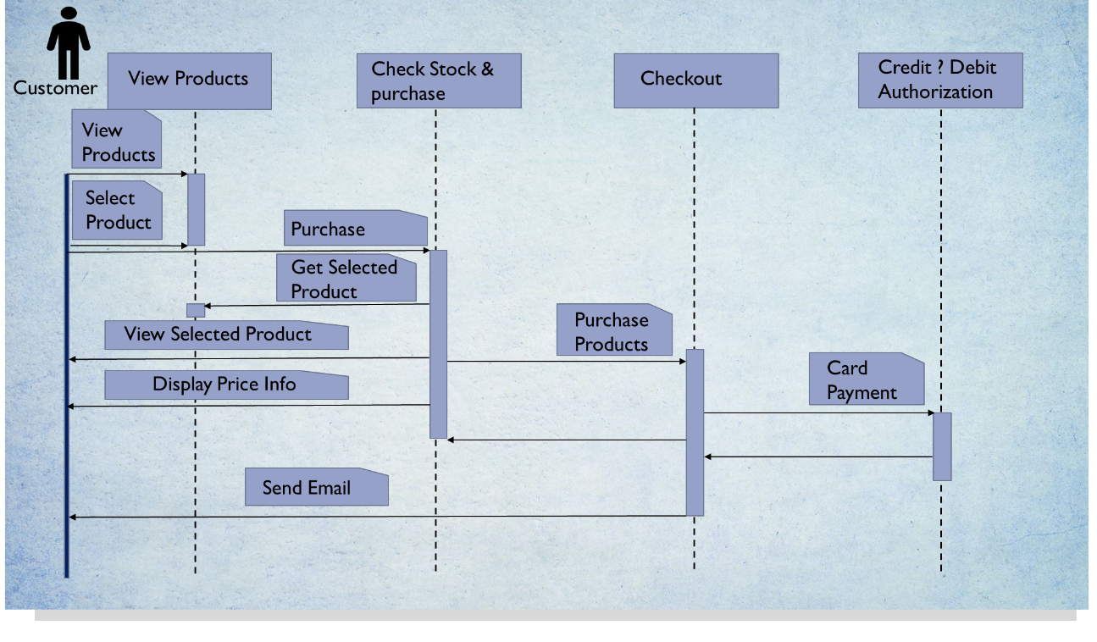

**2)Use Case Diagram**

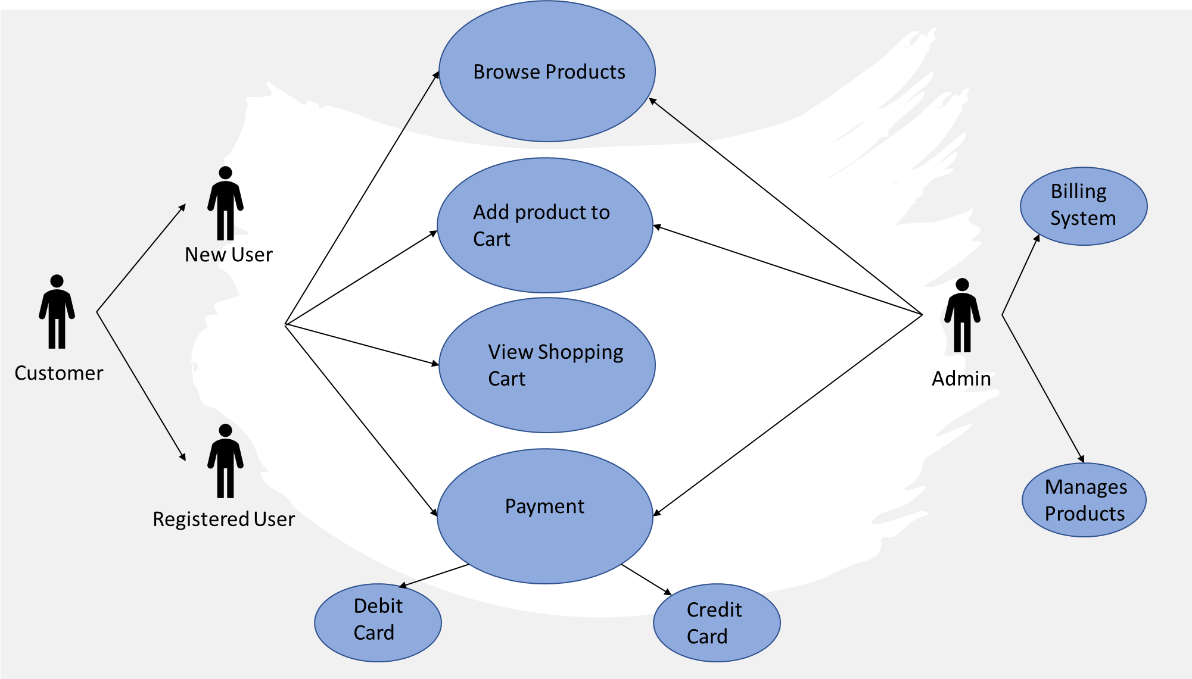

**DATABASE**

-Database Info

Collections required

Products

Users

Credentials(email pass)

Orders

Transaction

Schema for collection

Product

{

"_id":

"title":

"description":

"category"

"brand":

"exp_date":

"mfd_date":

"size":

"price":

"stock":

"images":[]

"remarks":[]

"reviews":[]

"rating":

}

Users

{ _id : ,

name :,

email : ,

mobile : ,

image :,

payment_mode : ,

payment_details : [ ], // sub-document this is arr of obj with card info

reg_date :,

}

Users Sub-document Object (payment details in above payment_details)

{ card_name :

card_number :

card_type :

card_bank :

card_brand :

exp_date : }

Credentials

{ _id : “an uuid”,

email : “user email id”,

password : “user password” }

Orders

{

_id :

user_id :

trans_id :

products : [ ] // sub-document,

date :

status :

}

Orders Sub-document Object (pructs details rrquired in Orders collection)

{

id :

name :

amount :

image :

}

Transactions

{

_id :

user_id :

order_id :

amount :

card_no :

pay_date :

pay_mode :

}